Data base is a collection of table we can find the table columns here

If we want to edit the font of the query which is this:

We select edit preferences: front and colors and change the number on the editor.

The grid is the all the table shown down in the SQL page

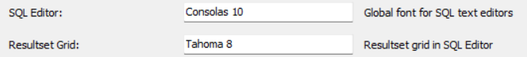

The star between select and from means all the columns



To select only two columns we can type this in the place of all the columns

We can change the editor to show us what we need to see the end should be ended with comma point,

The other method to do this is set as **default schemas**,by right click on the **table name** and select **default schemas**.

**Text query:**

**And here is shows the number of rows and how much time it takes to fetch this data: **

**To check how many industries are there:**

**Here we are looking for a movie with the title of Thor and the % in between mean any character could be found between the Thor names. This is called a wild card search.**

**Exporting result:**



**Problem solving;**

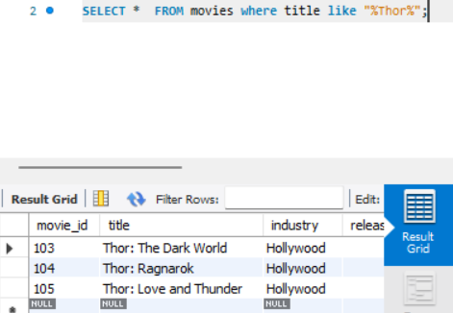

**Multiple tables;**

**We can use the abbreviation**

**Inner join:**

**It takes only into account the common records:**

**Left join/ right join**

**The representation of this will be like this**

**We need to make sure about the join table from wich we take our data,**

**Union**

**Using**

**we shouldn’t write from where we are taking the movie id here because it is smart**

**We can use join for multiple columns as well**

